**Arrow Notation**

This is commonly used to show that our input and/or output are approaching specific values. We have already used this notation for the end behavior of polynomial functions.

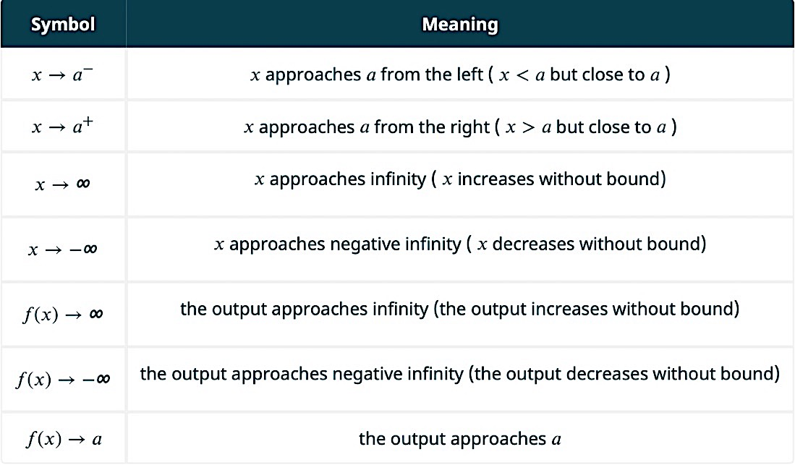

**Rational Functions**

A rational function is the quotient of two polynomial functions.

$$r\left(x\right)=\frac{a_{n}x^{n}+…+a_{0}}{b_{m}x^{m}+…+b_{0}}$$

The **end behavior** of a rational function is explained by the ratio of the lead terms:

$$As x→±∞, r\left(x\right)→\frac{a_{n}x^{n}}{b_{m}x^{m}}$$

The $y$**–intercept** of a rational function is the ratio of the constant terms:

$$r\left(0\right)=\frac{a_{o}}{b_{o}}$$

The **domain** of a rational function is all real numbers except those that cause the denominator to equal 0. This is equivalent to all real number except the zeros of the polynomial function in the denominator.

Each domain restriction is either a vertical asymptote or a hole (removable discontinuity). Vertical asymptotes are unique zeros of the polynomial in the denominator. Holes are common zeros of the polynomials in the numerator and denominator.

The **zeros** or $x$–intercepts of a rational function are the zeros of the polynomial in the numerator that are different from the zeros of the polynomial in the denominator.

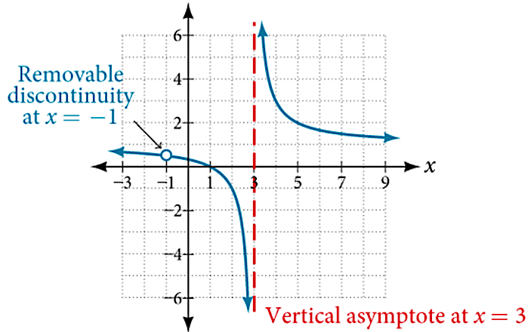Here is the graph of $r\left(x\right)=\frac{x^{2}-1}{x^{2}-2x-3}=\frac{\left(x+1\right)\left(x-1\right)}{\left(x+1\right)\left(x-3\right)}≈\frac{x-1}{x+3}$

The zero is $x=1$ (unique zero of the numerator)

The $y$–intercept is $r\left(0\right)=\frac{-1}{-3}=\frac{1}{3}$

The end behavior is horizontal: As $x→±∞, r\left(x\right)→\frac{x^{2}}{x^{2}}=1$

Note that the domain restrictions are $x≠-1$ (common zero and thus a hole is created) and $x=3$ (unique zero of the denominator and thus a vertical asymptote is created).

Example 1: Determine the end behavior, $y$–intercept, and domain of the following rational functions. Also state whether each domain restriction is a vertical asymptote or a hole.

$r\left(x\right)=\frac{2x(x-3)(x+4)}{(x-1)(x+2)(x+4)}$

$s\left(x\right)=\frac{x^{2}+3x-10}{x^{3}-2x^{2}-3x+6}$

**Hole Location**

Since a hole is a removable discontinuity, we can determine the location of the hole by evaluating the **reduced form** of the rational function.

Example 2: Determine the location of the hole for the rational function below.

$r\left(x\right)=\frac{(x-1)(x+5)(x-2)}{(x-1)(x+3)}≈$

**Slant/Oblique/Linear Asymptote**

When the ratio of lead terms for a rational function results in $mx$, where $m$ is a real number, we have an end behavior that is linear. To determine the equation of the asymptote simply divide.

Example 3: Determine the end behavior of the rational functions.

$r\left(x\right)=\frac{3x^{2}-2x+1}{x-1}$

$q\left(x\right)=\frac{x^{3}-{6x}^{2}+3x}{2x^{2}-1}$

**Graphs of Rational Functions**

To graph a rational function without technological support, first determine the end behavior, $y$–intercept, zeros (including multiplicity), vertical asymptotes, hole, etc. Then sketch a graph using the information you found, or if you are still uncertain of how the graph behaves at specific inputs, simply test a point.

Example 4: Graph the following rational functions.

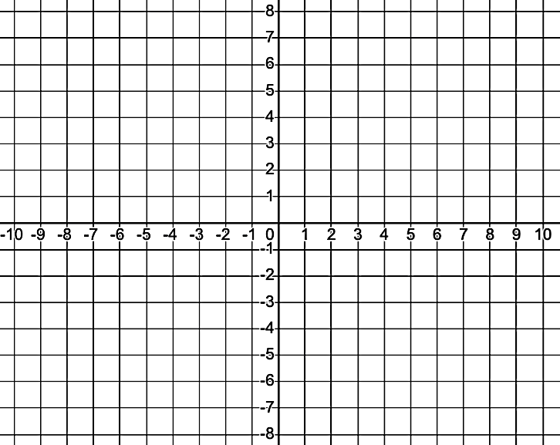



Example 5: Determine a potential rational function for the given graph.

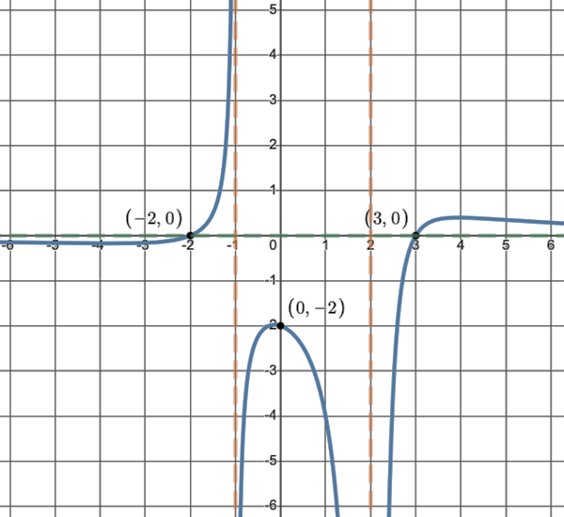

Example 6: Graph the rational function.

$r\left(x\right)=\frac{(x+4)(x+2)(x-1)}{(x+2)(x-3)}$